GCSE PE
Name …………………………………………..

Tutor…………………………………………….

Teacher…….………………………………….

Revision Booklet – Paper 1
Paper 1 –Anatomy & Physiology

About the Paper:
- 1 hour Paper – 60 marks total
- 20 Questions in Section A (30 marks)
  - These are shorter answers, focusing on your overall knowledge. It will include identify/label, multiple choice and describe stated topics.
- 3 (A&B) Questions in Section B (30 marks)
  - This section will test your application of knowledge. It will give you information and ask you to identify the topics it wants you to discuss.

What will be in your Paper?
- Location of major bones
- Functions of the skeleton
- Types of Synovial Joints
- Types of Movements at Hine and Ball & Socket Joint
- The roles of muscles in movement
- Short and Long Term Effects of exercise
- Components of Fitness
- Principals of Training (SPOR & FITT)
- Structure and function of the respiratory system
- Aerobic and Anaerobic respiration
- Structure and function of the cardiovascular system
- Planes of Movement and Axes of Rotation
- Lever Systems
- Optimising Training
  - Methods of training
  - Warm Up
  - Cool Down
- Prevention of Injury

How to use this booklet:
- You should use the sections in this booklet to help you revise each section.
- This booklet contains space to make notes on the main points from each section of the specification, but by no means are any of the sections exhaustive.
- In addition to this booklet, you should make additional notes, do further reading and practice past exam questions on each topic.
The Skeletal System

The 5 functions of the skeleton, including a brief description & practical examples:

Can you label these bones?

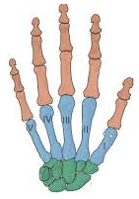

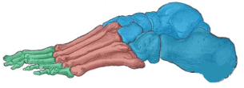

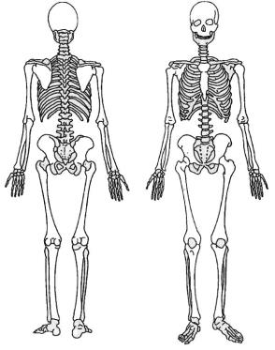
Can you label these bones?

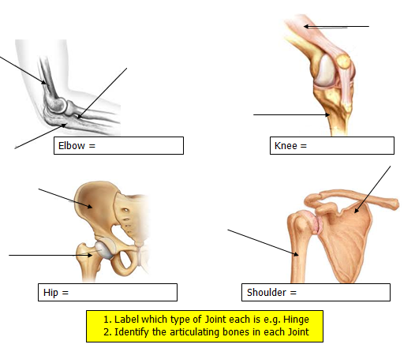
Types of Joints

Synovial Joints
Description of a ball and socket joint:
BALL & SOCKET JOINT:
Example of one in use:
Examples of ball and Socket joints:
Description of a hinge joint:
HINGE JOINT:
Example of one in use:
Examples of hinge joints:
Can you label the joint?

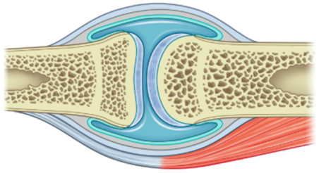

TIP: If you are asked to describe a joint – picture this diagram and describe all of the components (i.e. two bones meeting, cartilage, synovial membrane, synovial fluid etc…

Can you identify the structure and role of these parts of a synovial joint including the connective tissues:

 | Structure | Role/Function
Synovial membrane
Synovial Fluid
Cartilage
Tendons
Ligaments

Tip: You must be able to give 3 points for each of the connective tissues including both about their structure and function?

Ranges of Movement
You should be able to describe and give examples for each range of movement:
ADDUCTION
Description
Practical Example:
EXTENSION
Description
Practical Example:
ABDUCTION
Description
Practical Example:
CIRCUMDUCTION
Description
Practical Example:
ROTATION
Description
Practical Example:
FLEXION
Description
Practical Example:

Muscles
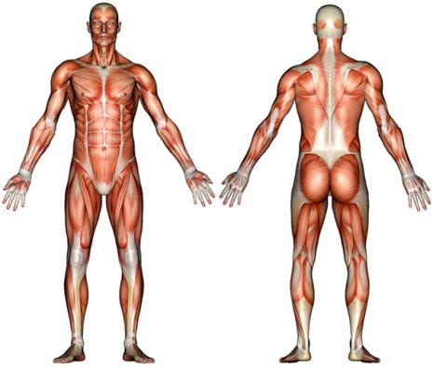

Label the diagram above, using the muscle names below.

Deltoid Triceps Trapezius Abdominals Latissimus Dorsi

Quadriceps Pectorals Hamstrings Biceps Gastrocnemius Gluteals
 | Description | Example
Antagonistic Pair
Agonist
Antagonist
Fixator

Can you work out which muscles are responsible for each movement?
Movement | Agonist | Antagonist | Fixtaor
Flexion of the knee
Extension of the elbow
Extension of the knee
Flexion of the elbow

TIP: Act out the movement to allow you to see it in action (even in the exam) then have a feel to see which muscles are contracting and which are relaxing. You should also be able to talk about agonists and antagonists for adduction and abduction.

Levers
Levers allow efficiency movement and create a mechanical advantage. They include:
Lever Arm Pivot/Fulcrum Effort/Force Load

Complete the table below:
Levers | Diagram | Example in Body
1st
2nd
3rd

TIP: Remember 1,2,3…FLE (this tells you which element is in the middle of the lever e.g. 1st class lever the fulcrum is in the middle)
What is the formula for Mechanical Advantage?

Planes of Movement

Plane | Movement | Axis of Rotation | Example
Sagittal
Transverse
Frontal

Planes of movement explain how the body moves it is useful o see the body having imaginary lines or planes running through it.
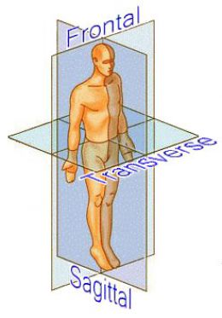
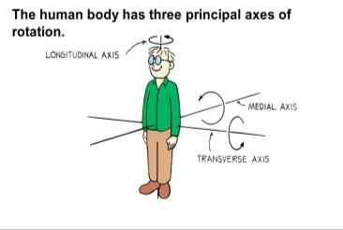

An Axis of rotation is a straight line which an object rotates.
The movement at a joint takes place in a plane about an axis.

TIP: Link the plane of movement and axis of rotation. Then think of multiple examples for the exam.
Respiratory System

Label the respiratory system

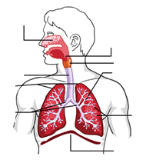

Describe how Gaseous Exchange occurs?

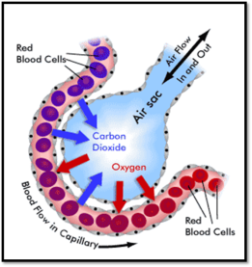

Mechanics of Breathing

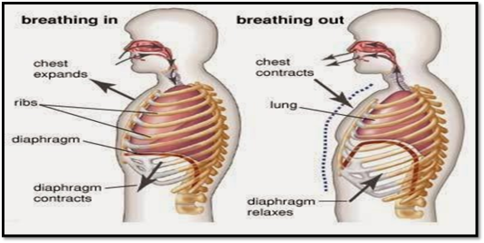

Here are the key points for the mechanics of breathing. All you need to do is add the correct words for either inspiration or expiration into the box below
- Diaphragm and External Intercostal muscles ____________
- This causes the Diaphragm to ________ and the Ribs and Sternum move ____________
- The Thoracic cavity volume _________
- The Lungs are ________ in size
- The air pressure ________ below atmospheric air
- Air rushes _______ the lung

Describe the mechanics of breathing in stages.
Inspiration Expiration

Tidal Volume (TV)–
This is the ______________ of air either inspired or expired _________________

Minute Ventilation (VE)–
This is the ______________ of air that is inspired or expired in a _______________

Breathing Rate (BR) -
The frequency measured in ___________________________

Equation for Minute Ventilation

VE =

This is measured in LITRES per minute!
Cardiovascular System

Label the diagram of the double circulatory system

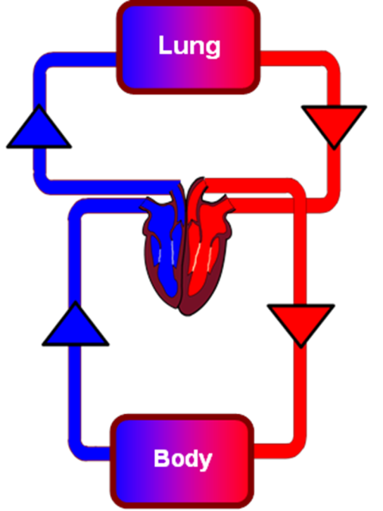

- Can you add in the 4 Valves of the Heart?

Blood Vessels | Description | Role
Artery
Vein
Capillary

- What is the purpose of a valve?

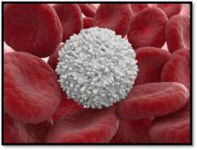
TASK: Label each blood cell with its role in the body
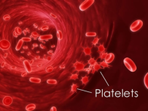
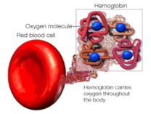

Heart Rate (HR)–
Is the number of _____________________________ (BPM)

Stroke Volume (SV) –
The ______________ of blood pumped out of the heart per ____________

Cardiac Output (Q) –
The ______________ of blood that is pumped out of heart per __________________

Cardiac Hypertrophy –
Increase in cardiac muscle _________

Peak Heart Rate
The Highest recorded bpm __________________________

Maximum Heart Rate
This is the maximum your heart can _____________ per minute (BPM).

HRmax = ______________________

Recovery Rate
How long it takes for a person’s heart rate to ________________ to its _____________ heart rate after training. The quicker this happens, the _____________ the person is.

- What is the equation for Cardiac Output?

Q =

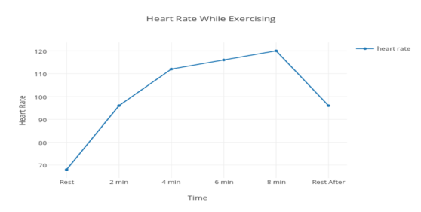

What does the graph show you?

Effects of Lactic Acid

- Lactic Acid occurs when (doing what?)…

- Lactic acid can lead to (effects)…

- The effects of lactic acid on performance can be decreased by (what methods?)…

TIP: Never include cramp in an answer on Lactic Acid – they are two different things!
COOL DOWNS – Speed up the REVOMAL of Lactic Acid they do not prevent it

Short-Term and Long-Term Effects of Exercise

R
E
S
P
I
R
A
T
O
R
Y

C
A
R
D
I
O
V
A
S
C
U
L
A
R

M
U
S
C
U
L
A
R

Describe the VASCULAR SHUNT MECHANISM as a short-term effect of exercise on the CV system:
Components of Fitness

Definition

Practical Example

Definition

Practical Example

Definition

Practical Example

Definition

Practical Example

Definition

Practical Example

Contribution to healthy balanced lifestyle

Contribution to healthy balanced lifestyle
Contribution to healthy balanced lifestyle
Contribution to healthy balanced lifestyle
Contribution to healthy balanced lifestyle

Components of Fitness continued…

Definition

Practical Example

Definition

Practical Example

Definition

Practical Example

Definition

Practical Example

Definition

Practical Example

Contribution to healthy balanced lifestyle

Contribution to healthy balanced lifestyle
Contribution to healthy balanced lifestyle
Contribution to healthy balanced lifestyle
Contribution to healthy balanced lifestyle

Describe up to two fitness tests for the following components of fitness

Test 1

Test2

Cardio Vascular Endurance

Test2

Test 1

Muscular Strength

Test 1

Speed

Test 1

Flexibility

Test 2

Test 1

Muscular Endurance

Test 1

Balance

Coordination
Test 1

Test 1

Agility

Test 1

Reaction Time

Test 2

Test 1

Power

Principle of Training

 | Description | Example
S
P
O | Links to FITT
R
T
F
I
T
T

Types of Training
Provide a description and an example for each of the following types of training:
WEIGHT

FARTLEK

HIIT

PLYOMETRICS

CIRCUIT

INVERVAL

Continuous

Aerobic and Anaerobic Respiration
You should also be able to define, describe and explain what Aerobic and Anaerobic Exercise is and what the differences are between the two:
AEROBIC

Practical Example of Aerobic Exercise:
ANAEROBIC

Practical Example of Anaerobic Exercise:

Potential Hazards
You also need to be aware of potential hazards in the following areas:

 | Potential Hazards | Risks
- The gymnasium
- Sports hall
- Fitness centre
Playing Field
Outdoor Adventurous Areas
Artificial Outdoor Areas (Astro)
Court Areas
Swimming Pool

TIP: A lot of the hazards are interchangeable between different environments. Just make sure that you make it specific to the area you are being asked about in an exam, especially if you are giving practical examples.

Minimising Risks
TIP: Make your examples specific to a certain activity! i.e. Using ropes when rock climbing to prevent falling from height.

Describe how each of the below can help minimize risks in the sporting environment. You should be able to provide examples for each:

- What is a Hazard?

- What is a Risk?

- What is an injury?

Minimising the Risk | How does this minimise risk? | Examples
Correct clothing/footwear
Personal protective equipment
Warm up and Cool Down
Lifting, carrying and placing equipment safely
Appropriate level of Competition
Why is personal hygiene important to avoid infections?

Common Sporting Injuries
What are the 7 common sporting injuries? Complete the table below:

Injury | Description | Treatment

15 TOP REVISION TIPS:

- Start revising in plenty of time for your exam
- Make a revision timetable (see overleaf)
- Revision notes aren’t supposed to look pretty – don’t waste time doing this!
- Revise in 45 minute blocks, with 10 minute rest breaks
- Revise in a clean, tidy and organised environment
- Prioritise your revision (using the table at the front of this booklet)
- Don’t spend too much time looking over topics you understand well – your time is better spent on areas you don’t understand as well
- Get at least 8-10 hours sleep per night
- Wake at a reasonable time (i.e. 9AM to begin revising) you are more productive in the morning and it means you can get your revision done early and have time to relax in the evenings
- Eat and drink well – avoid sugary, fizzy and energy drinks and eat a healthy, balanced diet
- EXERCISE – exercise helps clear the mind and increase concentration, always make time to exercise
- Have a rest day each week to just allow yourself to relax
- Stick revision notes around the house – on the fridge, in the bathroom, on your bedroom walls.
- Keep your bedroom and particularly your desk/table neat and tidy
- Practice past exam papers and learn what the mark schemes are looking for.
Notes

Notes

Notes

Notes

Notes

