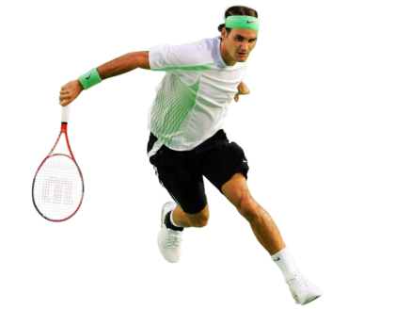
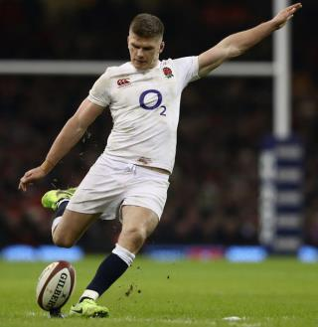
GCSE PE
Name …………………………………………..

Tutor…………………………………………….

Teacher…….………………………………….

Revision Booklet – Paper 2
Paper 2 – Socio-Cultural Issues and Sports Psychology

About the Paper:
- 1 hour Paper – 60 marks total
- 20 Questions in Section A (30 marks)
  - These are shorter answers, focusing on your overall knowledge. It will include identify/label, multiple choice and describe stated topics.
- 3 (A&B) Questions in Section B (30 marks)
  - This section will test your application of knowledge. It will give you information and ask you to identify the topics it wants you to discuss.

What will be in your Paper?
- Physical activity and sport in the UK
- Participation in physical activity and sport
- Commercialisation of sport
- Ethics in sport
- Drugs in sport
- Violence in Sport
- Characteristics of Skilful movement
- Classification of skills
- Goal Setting
- Mental Preparation
- Types of Guidance
- Types of Feedback
- Health, fitness and well being
- Diet and Nutrition

How to use this booklet:
- You should use the sections in this booklet to help you revise each section.
- This booklet contains space to make notes on the main points from each section of the specification, but by no means are any of the sections exhaustive.
- In addition to this booklet, you should make additional notes, do further reading and practice past exam questions on each topic

Engagement patterns of different social groups
What are the roles and any examples of the following organisations?

What sports have the highest participation and why?

What are the Government recommendations for exercise?
Adults:

Children:

What is a sedentary lifestyle?

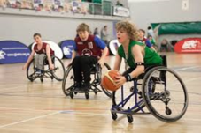
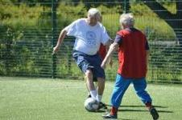

Explain why participation rates vary between the following?
GENDERS

ETHNIC GROUPINGS

AGE GROUPS

ETHNIC MINORITIES

DISABILITY

What are some of the Factors affecting participation in Sport?

What are the strategies to improve participation?

Can you identify the national campaigns Sport England and the Government have put into place to help improve participation and health
National Campaigns to improve health

Drugs
Explain the effects of performance enhancing drugs on performance and participation?
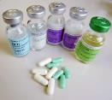
Steroids

Performance Side Effects

Beta-Blockers

Performance Side Effects

Stimulants

Performance Side Effects

Other than physical side effects what are some of the negative impacts of taking drugs for sports performers?

Violence
Sometimes player’s emotions get the better of them and they are violent on the pitch. You will need to know what factors can cause this violence?

What are the reasons for player violence?

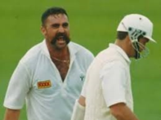
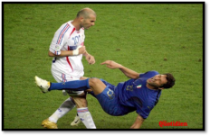
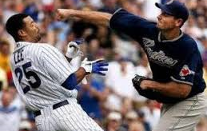

Media and Sponsorship
What are the positives and negatives of the Media and Sponsorship on Participation?
SPONSORSHIP
What is Sponsorship? How can it affect participation?

COMMERCIALISATION
What is Commercialisation? How can it affect participation?

NEGATIVES
Negatives of media

POSITIVES
Positives of media
Classification of Skill

A Motor skill is a __________________________________________________response

Classification makes it clearer about what is required to learn and perform a particular skill

They are placed on 2 continuums
- Environmental (OPEN/CLOSED)
- Difficulty (COMPLEX/SIMPLE)

Environmental Continuum (Open/Closed)

Closed
Open

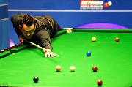
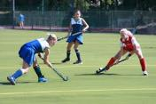

Difficulty Continuum (Simple/Complex)

Complex
Simple

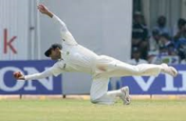
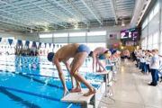

Describe at least 5 Characteristics of a skillful movement

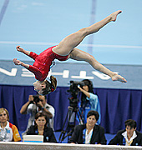

Can you give a practical example of how each would apply?
Characteristic | Practical Example

Can you identify the difference between a Skilled and Unskilled Performer?
Skilled Performer | Unskilled Performer

Goal Setting
Give 3 reasons as to why Goal Setting is important:

Do you know and understand the SMART goal setting principle, with practical examples?

S

M

A

R

T

Mental Preparation Techniques
To cope with high levels of anxiety and emotions when performing

Description

Practical Example

Description

Practical Example

Description
Description

Practical Example
Practical Example

What are the benefits of being mentally prepared?

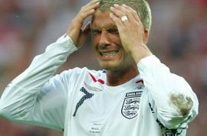
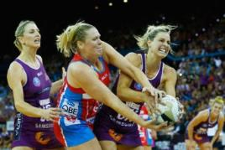
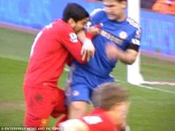

Reasons why it’s important to control emotions?

Types of Guidance
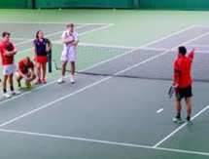
_______________ Guidance
_______________ Guidance

E.g.,..
E.g.

What are the advantages?
What are the advantages?

What are the disadvantages?
What are the disadvantages?

What are the advantages?
What are the advantages?

What are the disadvantages?
What are the disadvantages?

_______________ Guidance
_______________ Guidance
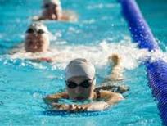
E.g.,..
E.g.,..

Types of Feedback
Extrinsic Feedback
Description

Practical Example(s)

Knowledge of Results
Description

Practical Example(s)

Knowledge of Performance
Description

Practical Example(s)

Intrinsic Feedback
Description

Practical Example(s)

Other Types of Feedback:

- Mental Preparation

Key Components of Diet
Effect on the body
Food example

Effect on the body

Food example

Effect on the body

Food example

Effect on the body

Food example

Effect on the body

Food example

Effect on the body

Food example

Effect on the body

Food example

Energy Balancing
-
+

Characteristics of a Healthy Lifestyle

BMI Formula

Describe what is BMI and how is it calculated?

Benefits of a healthy active lifestyle
Can you add as many benefits of an active lifestyle for each category as you can.
 | Factor | Benefits
Physical
Social
Emotional

Tip: Read the question carefully – is it looking for a specific benefit e.g. physical only??
15 TOP REVISION TIPS:

- Start revising in plenty of time for your exam
- Make a revision timetable
- Revision notes aren’t supposed to look pretty – don’t waste time doing this!
- Revise in 25-45 minute blocks, with 5-10 minute rest breaks
- Revise in a clean, tidy and organised environment
- Prioritise your revision (using the table at the front of this booklet)
- Don’t spend too much time looking over topics you understand well – your time is better spent on areas you don’t understand as well
- Get at least 8-10 hours sleep per night
- Wake at a reasonable time (i.e. 9AM to begin revising) you are more productive in the morning and it means you can get your revision done early and have time to relax in the evenings
- Eat and drink well – avoid sugary, fizzy and energy drinks and eat a healthy, balanced diet
- EXERCISE – exercise helps clear the mind and increase concentration, always make time to exercise
- Have a rest day each week to just allow yourself to relax
- Stick revision notes around the house – on the fridge, in the bathroom, on your bedroom walls.
- Keep your bedroom and particularly your desk/table neat and tidy

Notes

Notes

Notes

Notes

Notes

